

**KABARAK UNIVERSITY**

**SCHOOL OF SCIENCE, ENGINEERING AND TECHNOLOGY (SSET)**

**DEPARTMENT OF COMPUTER SCIENCE**

**COMP 411 : RESEARCH PROJECT I**

**WEB BUILDER AND CONTENT MANAGEMENT SYSTEM (CMS)**

**By:**

**TIMOTHY CHRISTOPHER AWINIA - CS/M/0741/05/22**

This project is submitted in Partial Fulfillment of the Requirements for the Degree of Batchelor of Science in Computer Science at Kabarak University.

MAY – AUGUST 2024

# **DECLARATION**

I declare that this is my original work based on my investigations and inquiries in the research. It has never been submitted or published by any other student.

Sign………………………………………………….... Date…………………………

TIMOTHY CHRISTOPHER AWINIA

This proposal has been submitted for examination by the above-named student with my approval as University Supervisor.

Sign………………………………………………….... Date…………………………

CEH CHRISPUS ALUKWE

# **ACKNOWLEDGEMENT**

I would like to express my sincere gratitude and appreciation to all those who have contributed to the successful completion and preparation of this project proposal. First and foremost, I extend my heartfelt gratitude to the Almighty God for the charitable time, good health, strength and aptitude that enable me to complete my proposal. I am also grateful to my supervisor CEH CHRISPUS ALUKWE. His unwavering support, invaluable guidance, and encouragement throughout has been instrumental in shaping my understanding towards writing this proposal.

I am deeply appreciative of the valuable feedback and inputs received from him. His constructive recommendations have helped me refine my research and analysis, leading to a more comprehensive and coherent proposal. I would also like to extend my gratitude to my family and friends for their continuous encouragement and understanding during this research period. Their unwavering support has been a source of motivation and strength.

# **DEFINITION OF TERMS**

**Software known as content management systems (CMS):** is software that helps users create, manage, and modify content on a website without the need for technical knowledge. In other words, a CMS lets you build a website without needing to write code from scratch (or even know how to code at all).

**Drag-and-drop functionality:** This graphical user interface feature makes website design easier without requiring coding by enabling users to choose things and move them around the interface with a mouse or touch.

**User Experience (UX):** UX design combines visual design, usability, and functionality to create products that offer users meaningful and relevant experiences.

**Non-Technical users:** These are users that have minimal or no technical skill in the development of websites or web apps.

**Technical users:** These are users with medium to high level technical skills in the development of websites or web apps.

# **ABSTRACT**

This project aims to design and develop a platform for non-tech users to build websites seamlessly without having to learn any major technical skills. The system provides a drag and drop functionality to allow users to design the website to their preferences while adding a layer of abstraction in the code base, allowing the user to export the final product once the design is complete.

The project involves creating a web-based application using HTML, CSS, and JS, for the frontend and web builder functionality and PHP and MySQL for the backend, this system will feature a secure login system to be able to create user account, provide a UI based drag-and-drop interface for user web development, the system will also provide A CMS functionality to store the data used temporarily and allow the user to export the website(web app).

Extensive research includes observations and analysis of data from other websites to determine current functionalities and determine improvements to the current features with the intended user in mind. This project represents a significant advancement in the world of web design and potentially web development, allowing even more accessibility for tech and non tech users.

# **TABLE OF CONTENT**

**DECLARATION** i

**ACKNOWLEDGEMENT** ii

**DEFINITION OF TERMS** iii

**ABSTRACT** iv

**TABLE OF CONTENT** v

**LIST OF FIGURES** vi

**LIST OF TABLES** vii

**CHAPTER 1: INTRODUCTION** 1

**1.1 BACKGROUND OF THE STUDY** 1

**1.1.1 AUDIENCE AND PROBLEM DEFINITION** 1

**1.1.2 HISTORICAL CONTEXT** 2

**1.1.3 THEORETICAL CONTEXT** 2

**1.2 STATEMENT OF THE PROBLEM** 3

**1.3 OBJECTIVES** 4

**1.3.1 GENERAL OBJECTIVE** 4

**1.3.2 SPECIFIC OBJECTIVE** 4

**1.4 RESEARCH QUESTIONS** 4

**1.5 SIGNIFICANCE OF THE STUDY** 4

**1.6 SCOPE AND LIMITATIONS OF THE STUDY** 6

**1.6.1 SCOPE OF THE STUDY** 6

**1.6.2 LIMITATIONS OF THE STUDY** 6

**CHAPTER TWO: LITERATURE REVIEW** 8

**2.0 INTRODUCTION** 8

**2.1 User Interface Design** 8

**2.2 Integration of AI and Automation** 8

**2.3 Impact of Educational Resources** 9

**2.4 Concept Map** 9

**2.5 Conclusion** 10

**CHAPTER THREE: METHODOLOGY** 11

**3.0 INTRODUCTION** 11

**3.1 RESEARCH METHODOLOGY** 11

**3.2 DATA COLLECTION METHODS** 11

**3.3 DESIGN DIAGRAMS** 12

**3.3.0 CONTEXT DIAGRAM** 12

**3.3.1 LEVEL 1 DFD** 13

**3.3.2 USE-CASE DIAGRAM** 14

**3.4 RESEARCH ETHICS** 14

**3.4.1 INTRODUCTION** 14

**3.4.2 RESEARCH DESIGN** 15

**CHAPTER FOUR: SYSTEM IMPLEMENTATION** 17

**4.1 INTRODUCTION** 17

**4.2 SYSTEM ARCHITECTURE** 17

**4.3 FRONT-END DEVELOPMENT** 17

**4.4 USER INTERFACE DESIGN** 20

**4.5 USER INTERFACE MODULES** 21

**4.5.1 Login System** 21

**4.5.2 Dashboard** 21

**4.5.2 Dashboard** 22

**4.6 BACK-END DEVELOPMENT** 22

**4.6.1 Database Design Models** 23

**4.6.2 Database Tables** 24

**4.6.3 Code Testing** 25

**4.7 DEPLOYMENT METHODS** 25

**5.0 CONCLUSION AND FUTURE WORK** 25

**APENDIX C: PROJECT SCHEDULE** 28

**APENDIX D: BUDGET** 28

# **LIST OF FIGURES**

Concept map …………………………………..………………………………………………….9

Context Diagram ……………………………………………………………………………….. 11

Level 1 DFD …...……………………………………………………………………………… 12

Use case Diagram ………………..…………………………………………………………….. 13

# **LIST OF TABLES**

Project Schedule ………………………………………………………………………………... 28

Budget ………………………………………………………..………………………………… 28

# **CHAPTER 1: INTRODUCTION**

Having an online presence is essential for individuals and businesses in today’s world, as it provides easy accessibility for marketing, sales, and communication to customers and individuals. However, because traditional web development requires a certain level of coding skills, developing a website remains a difficult task for non-technical individuals. Despite the fact that Content Management Systems (CMS) have made it easier to create and manage websites, many of them are still too complicated for non-technical users, which discourages them from creating an online presence and reduces their advantage over competitors.

This study suggests creating a drag-and-drop website builder CMS, in order to overcome these difficulties with the goal of democratizing web creation. An overview of the study's history, problem statement, purpose, goals, research questions, and significance is given in this chapter.

## **1.1 BACKGROUND OF THE STUDY**

Building a website that is both aesthetically pleasing and useful has become crucial for people and companies looking to make a big online impact. However, because of the conventional level of technical competence needed, this work is frequently seen as complex. In order to comprehend the difficulties non-technical users encounter in web development, it is necessary to examine important terminologies, ideas, and background information.

### **1.1.1 AUDIENCE AND PROBLEM DEFINITION**

Non-technical users, including small business owners, freelancers, and individuals seeking to build personal websites, often face challenges due to the complexity of coding and intricate CMS interfaces. This situation hinders their ability to establish and manage professional websites, impacting their competitiveness in the online marketplace. The rise of no-code platforms aims to address these challenges by enabling website creation without coding skills. However, these platforms also present limitations, such as scalability concerns and integration challenges. (Daniel Raymond, 2024)

For instance, small business owners often struggle with poor website design due to inexperience in web development, leading to high bounce rates and difficulties in scaling for growth (Jake Fellows, 2024). Additionally, while no-code platforms empower non-technical users, they may still encounter a learning curve and face limitations in technical depth. (Myroslav Budzanivskyi, 2024) <https://www.codebridge.tech/articles/low-code-and-no-code-development-opportunities-and-limitations?utm_source=chatgpt.com>)

Despite these challenges, the adoption of no-code platforms is increasing, offering non-technical users more control over website development. These platforms provide visual interfaces and pre-built templates, making website creation more accessible.

### **1.1.2 HISTORICAL CONTEXT**

Over the past two decades, there has been a substantial progress in web development tools. When websites were first created, a deep understanding of HTML, CSS, and JavaScript was necessary. This process was intended to be made simpler by early CMS platforms such as Dreamweaver (1997), FrontPage (1996), and GeoCities (1994). These systems still required a rudimentary understanding of coding, though. No-code web builders like Squarespace (2004), Wix (2006), and WordPress (2006) have been popular in recent years, making the process of creating websites easier to use, although they frequently lack the flexibility and customization that users desire. (John Hughes, 2023)

### **1.1.3 THEORETICAL CONTEXT**

This study's theoretical foundation is the Technology Acceptance Model (TAM), which posits that users' behavioral intention which is based on perceived usefulness and simplicity of use predicts technology acceptance. This project attempts to improve user acceptability and happiness by creating a web builder CMS that prioritizes ease of use with an intuitive drag-and-drop interface. (Davit Marikyan & Savvas Papagiannidis, 2023)

The platform will incorporate principles from the Human-Computer Interaction (HCI) domain, including affordance and cognitive load. While cognitive load relates to the mental work needed to operate the system, affordability refers to the characteristics that enable users to carry out an action. It seeks to deliver an ideal user experience by reducing cognitive burden and increasing affordance.

Additionally, Usability theory also emphasizes creating systems that are successful, efficient, and pleasurable to use, which informs the assessment of the platform. (Windlinger L., & Tuzcuoglu D. (2021))

## **1.2 STATEMENT OF THE PROBLEM**

The current state of web development tools makes it difficult for non-technical users to design and manage professional websites because of a number of important issues. The following issues are the focus of this study:

**Complexity of the majority of currently available content management systems (CMS):** CMS platforms such as WordPress, Joomla, and Drupal, are built for users with advanced technical skills. Non-technical users frequently lack the coding language skills necessary for these platforms, including HTML, CSS, and JavaScript. It is challenging for these users to use CMS platforms efficiently because of the barrier created by this complexity.

**Limited Flexibility in User-Friendly Website Builders:** Although drag-and-drop website builders like Wix, Squarespace, and Weebly provide user-friendly interfaces, they frequently lack the customization options and flexibility necessary to develop distinctive, fully functional websites. Users are unable to attain the appropriate degree of customization and functionality because of these restrictions.

**High Prices and Perceived difficulties:** Many small organizations and individuals are discouraged from building a strong online presence by the high costs and perceived difficulties of web creation. Because using expert web creation services is frequently viewed as an expensive and complicated endeavor, a sizable percentage of small firms do not have a professional website.

**Ineffective Content Management:** Ineffective content management systems are usually provided by website builders and current CMS platforms, making it difficult for non-technical users to update and maintain their website content. Reduced user engagement and out-of-date information are possible outcomes of this inefficiency.

## **1.3 OBJECTIVES**

### **1.3.1 GENERAL OBJECTIVE**

The Objective of this project is to democratize web development by offering a simple and intuitive platform that enables anyone to create a great website, regardless of technical proficiency.

### **1.3.2 SPECIFIC OBJECTIVE**

1. Research and analyze the features of current tools through SWAT analysis.
2. Design an intuitive user interface for a web builder CMS.
3. Develop an intuitive web builder CMS as well as testing with tech and non tech users.
4. Deploy the web builder CMS to a web server.

## **1.4 RESEARCH QUESTIONS**

1. How can I research and analyze the features of current tools through SWAT analysis.?
2. How can I design an intuitive user interface for a web builder CMS?
3. What are the steps used to Develop an intuitive web builder CMS as well as testing with tech and non tech users.?
4. Which web host server should I deploy the web builder CMS to?

## **1.5 SIGNIFICANCE OF THE STUDY**

There are a number of players in the digital ecosystem that stand to gain significantly from the anticipated development of the web builder CMS. The following are the main areas in which this study is highly valuable:

**Empower non-technical users in web development:** By bridging the gap between technical and non-technical users. This platform will make it possible for anybody with little to no coding experience to design and manage professional websites with an easy-to-use drag-and-drop interface. Small business owners, independent contractors, and individuals can now have a powerful online presence without having to pay for pricey expert services thanks to the democratization of web development.

**Enhancing Inclusion and Accessibility:** It encourages greater inclusion and accessibility by removing the technological obstacles to web creation. By enabling a wider range of people to engage in the digital economy, this can aid in closing the digital divide. Small enterprises can gain from greater visibility and competition in the global marketplace, especially those in underserved or less technologically sophisticated locations.

**Promoting Economic Growth:** For small businesses, establishing a credible internet presence is essential to drawing in clients, establishing brand loyalty, and increasing revenue. It may assist these companies in expanding and succeeding by offering an inexpensive and user-friendly web building solution. Broader economic advantages like the creation of jobs, heightened market rivalry, and general economic growth may result from this.

**Enhancing User Engagement and Experience:** It is anticipated that the study's emphasis on user experience (UX) and the usage of a drag-and-drop interface would increase user engagement and satisfaction. Improved customer satisfaction, user retention, and conversion rates can all be attained with a well-designed, user-friendly website. This can improve user experience overall and increase the efficacy of digital marketing campaigns.

**Contributing to Academic and Practical Knowledge:** From an academic standpoint, this research will add to the corpus of knowledge already available in the domains of web development, human-computer interaction (HCI), and information systems and technology. Future research and development initiatives can benefit from the knowledge gathered from the design, development, and evaluation, which could result in even more advancements in the sector.

**It promotes innovation in web development tools:** It is a development that advances the field, especially when it comes to no-code solutions. By exploring the limits of drag-and-drop functionality and user-friendly design, this project can stimulate fresh ideas and advancements in web builder platform development.

## **1.6 SCOPE AND LIMITATIONS OF THE STUDY**

### **1.6.1 SCOPE OF THE STUDY**

This study includes the planning, creation, and assessment of the content management system. The research will specifically focus on the following topics:

1. **User Interface construct:** The goal of the study is to develop a drag-and-drop interface that is simple enough for non-technical individuals to use and intuitive enough to construct professional websites.
2. **Feature Development:** A vast library of pre-built website templates, modifiable design elements, and smooth content management functionalities are among the important aspects that need to be created and incorporated into the web builder.
3. **Responsive Design:** It support for responsive design features will be examined in this study to make sure websites are usable and accessible on PCs, tablets, and smartphones, among other devices.
4. **Usability Testing:** To assess the platform's efficacy and user satisfaction, usability testing will be conducted with a set of target users, including individuals, freelancers, and small business owners.
5. **Comparative Analysis:** To illustrate the benefits and need for improvement, which will be compared with other web builder platforms currently on the market in terms of usability, flexibility, and user happiness.

### **1.6.2 LIMITATIONS OF THE STUDY**

This study has certain limitations that should be addressed, despite its extensive scope:

1. **Technical Restrictions:** It's progress may be hampered by technical restrictions, such as the lack of resources, frameworks, and development tools. The development process's efficiency and speed may be impacted by certain limitations.
2. **User Diversity:** Although a wide range of target users is intended to be included in the study, not all possible user demographics and interests may be fully represented. Instead of being intended for a wider audience, the findings might be more catered to particular groups, including freelancers and small business owners.
3. **Resource Restrictions**: The amount of time, money, and manpower that can be allocated to the study's preparation and testing stages may be limited. This might have an effect on the scope and depth of the testing and assessment procedure.
4. **Market Dynamics:** The market for web development is ever-changing and dynamic. The study may witness the emergence of novel technologies and platforms, which could have an impact on Its competitiveness and relevance.
5. **Scope of Features:** The study will concentrate on essential features required for website creation and management. Complex animations, sophisticated SEO tools, and e-commerce connection are examples of advanced features that might not be incorporated in the first development stage.
6. **User Feedback Implementation:** Although user feedback will be gathered and examined, technological viability and resource availability may limit the capacity to put all recommendations and enhancements into practice.

# **CHAPTER TWO: LITERATURE REVIEW**

### **2.0 INTRODUCTION**

The Introduction of web development was originally meant for sharing research documents across the world, the earliest technology being HTML invented by Tim Berners-Lee. Advancements in web development have occurred since then leading to building web applications, and making the development process simpler for the average developer, thus the invention of web builders. However, the web builders still require a certain level of technical skill, ones not accessible to non tech enthusiasts. Developing a user-friendly web builder is an essential step in democratizing web development.

This literature review critically examines existing research and tools related to web builders, focusing on their accessibility for non-tech users. The review will explore the effectiveness of various features in simplifying web development and identify gaps where improvements can be made. This chapter will be structured around three key objectives:

* Evaluating user interface design
* Assessing the integration of automation
* Examining the impact of educational resources on user success.

## **2.1 USER INTERFACE DESIGN**

User Interface (UI) design plays a crucial role in making web builders accessible to non-tech users. Studies such as Johnson (2019) and Smith (2020) have shown that drag-and-drop interfaces significantly reduce the learning curve for new users. However, challenges remain in ensuring these interfaces are intuitive and flexible enough to meet diverse user needs. For instance, Johnson's (2019) study highlights that while drag-and-drop features are generally well-received, users often struggle with customizing pre-designed templates to match their specific requirements. Smith (2020) further points out that the lack of inline editing capabilities can frustrate users who expect real-time feedback during the design process.

## **2.2 INTEGRATION OF AI AND AUTOMATION**

The integration of AI and automation in web builders can enhance user experience by providing personalized recommendations and automating repetitive tasks. Research by Williams et al. (2021) demonstrates that AI-driven template suggestions can help users quickly find suitable designs based on their content and preferences. Additionally, automated SEO tools, as discussed by Lee (2022), can assist users in optimizing their websites without needing in-depth knowledge of search engine algorithms. Despite these advantages, there is a gap in how effectively AI can adapt to the unique needs of different users, particularly those with limited technical skills. This gap presents an opportunity for further research and development to create more adaptive AI systems.

## **2.3 IMPACT OF EDUCATIONAL RESOURCES**

Educational resources are vital in supporting non-tech users in utilizing web builders effectively. According to Brown (2021), tutorials and in-app guidance can significantly improve user satisfaction and reduce the abandonment rate of web builders. However, the quality and accessibility of these resources vary widely among different platforms. Brown's (2021) research indicates that interactive tutorials and context-sensitive help are more effective than static documentation. Yet, many existing web builders still rely heavily on traditional help documents, which may not cater to all learning styles.

## **2.4 CONCEPT MAP**

The concept map below illustrates the relationship between the independent variables (UI design, AI integration, educational resources) and the dependent variable (user success in creating websites). The map highlights the gaps identified in the literature, such as the need for more intuitive customization options, adaptive AI systems, and diverse educational resources.

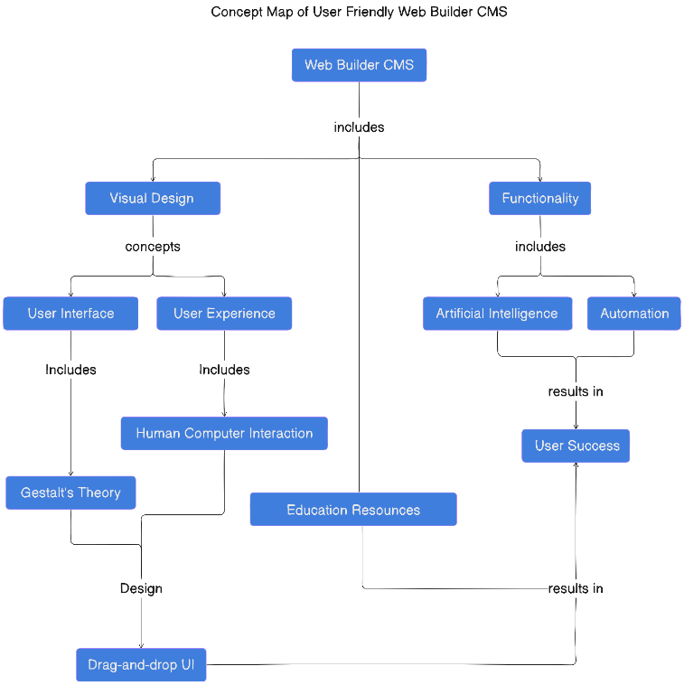

## **2.5 CONCLUSION**

The literature review highlights the importance of intuitive UI design, adaptive AI integration, and comprehensive educational resources in making web builders accessible to non-tech users. Addressing the identified gaps can significantly enhance the user experience and democratize web development.

# **CHAPTER THREE: METHODOLOGY**

## **3.0 INTRODUCTION**

This chapter outlines the methodology used in the development of the simple, intuitive web builder aimed at democratizing web development for non-tech users. It details the research design, data collection methods, design diagrams, and ethical considerations pertinent to the study.

## **3.1 RESEARCH METHODOLOGY**

The research design adopted for this study is a mixed-methods approach, combining both qualitative and quantitative research methods. This approach allows for a comprehensive understanding of the user needs and the effectiveness of the web builder in meeting those needs.

* **Qualitative Methods**: In-depth interviews and focus groups with potential users to gather insights into their experiences and challenges with existing web builders.
* **Quantitative Methods**: Surveys and usability testing to quantify user satisfaction and identify common issues faced by non-tech users.

This mixed-methods approach ensures a holistic understanding of the user experience and helps in designing a tool that is both user-friendly and effective.

## **3.2 DATA COLLECTION METHODS**

Data collection for this study will involve both primary and secondary sources.

* **Primary Data**:
  + **Surveys**: Online surveys will be distributed to a diverse group of non-tech users to gather data on their experiences, needs, and preferences.
  + **Usability Testing**: Participants will be observed while using the web builder to identify usability issues and areas for improvement.
  + **Interviews and Focus Groups**: Conducted with selected participants to gain deeper insights into their experiences and suggestions for improvement.
* **Secondary Data**:
  + **Literature Review**: Analysis of existing research and tools in the field of web builders to identify best practices and common pitfalls.
  + **Market Analysis**: Examination of current market trends and user demographics to ensure the tool meets the needs of its target audience.

## **3.3 DESIGN DIAGRAMS**

Design diagrams are crucial in visualizing the system architecture and user interactions. The following diagrams will be included:

### **3.3.0 CONTEXT DIAGRAM**

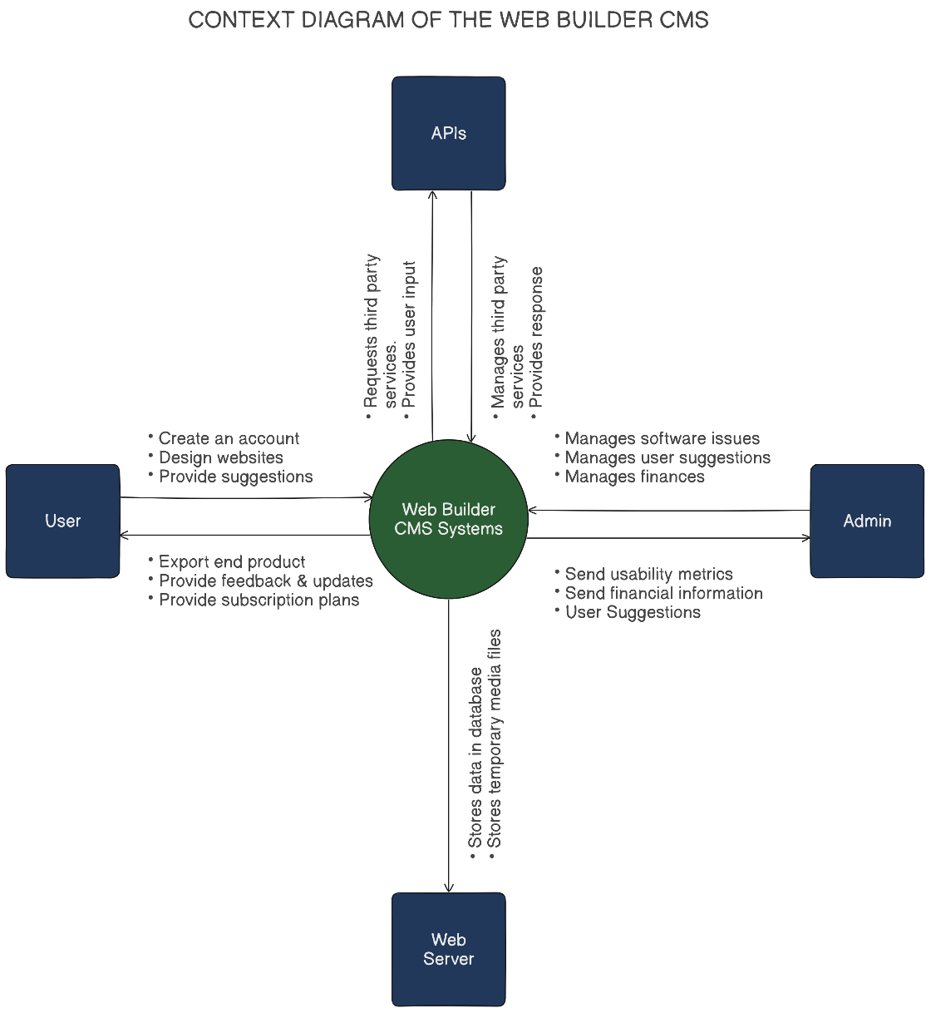

### **3.3.1 LEVEL 1 DFD**

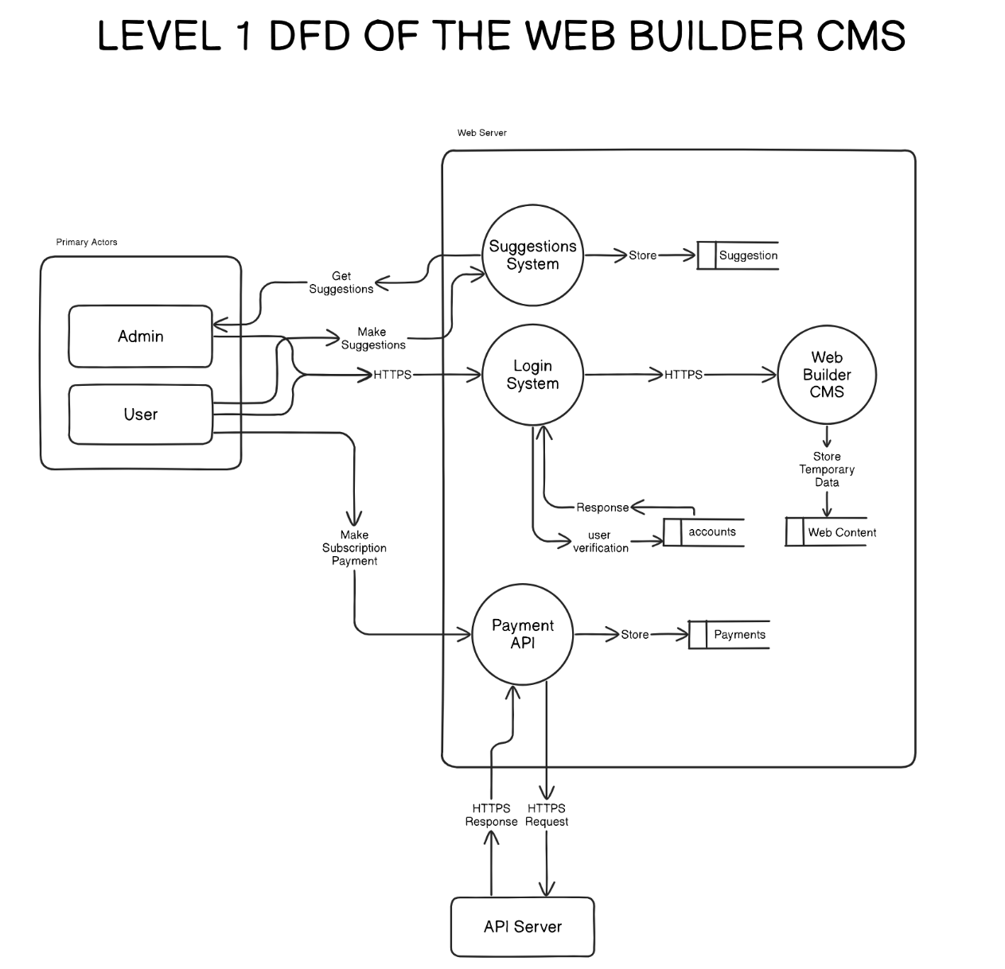

### **3.3.2 USE-CASE DIAGRAM**

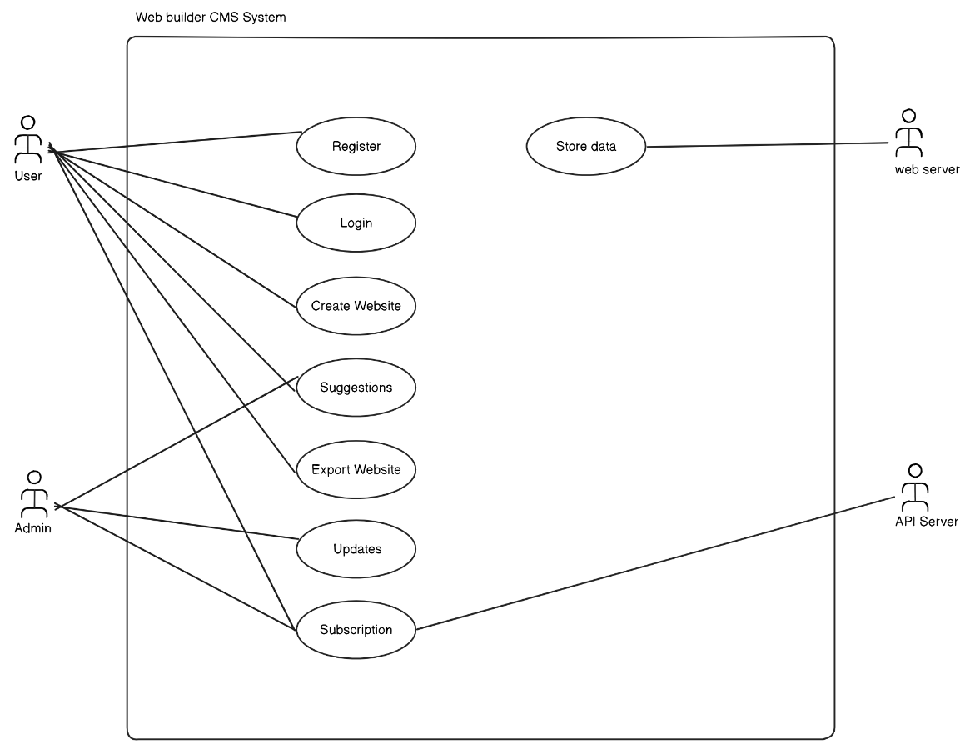

## **3.4 RESEARCH ETHICS**

### **3.4.1 INTRODUCTION**

This section outlines the research methodology used in developing the AI-powered Web Builder CMS. The methodology includes the research design, data collection methods, system development approach, and ethical considerations to ensure the study's validity and reliability.

Ethical considerations are paramount when conducting research involving human subjects. This study will adhere to the following ethical guidelines:

* **Confidentiality**: All data collected from participants will be kept confidential and used solely for the purposes of this research. Personal information will be anonymized to protect participant privacy.
* **Anonymity**: Participants' identities will be protected by assigning codes or pseudonyms to ensure their responses cannot be traced back to them.
* **Informed Consent**: Participants will be fully informed about the purpose of the study, the nature of their involvement, and their rights before participating. Written consent will be obtained from all participants.

### **3.4.2 RESEARCH DESIGN**

The research follows a **mixed-methods approach**, combining both **qualitative and quantitative methods**:

* **Qualitative Research**: Used to analyze user needs, UX challenges, and web development trends through literature reviews and expert interviews.
* **Quantitative Research**: Utilized for system performance testing, user surveys, and efficiency measurements of AI-generated designs.

The **system development life cycle (SDLC)** follows an **Iterative Model**, allowing continuous testing and refinement based on user feedback.

**3.4.3 DATA COLLECTION METHODS**

**Primary Data**

* **User Interviews & Surveys**: Collect insights from web designers, developers, and non-tech users on CMS usability.
* **Prototype Testing**: Users interact with the web builder to provide feedback on AI-generated site structures.

**Secondary Data**

* **Literature Review**: Examines AI in web development, best CMS practices, and usability heuristics.
* **Competitor Analysis**: Compares existing web builder platforms like Relume, Webflow, and Wix to identify gaps.

**3.4.4 RESEARCH ETHICS**

* **User Consent**: All participants in surveys and tests will provide informed consent.
* **Data Privacy**: User inputs and feedback will be anonymized and securely stored.
* **Intellectual Property**: The AI-generated designs will follow ethical AI practices to prevent copyright infringement.

**CONCLUSION**

This methodology ensures a systematic approach to designing and evaluating the AI-powered Web Builder CMS. By integrating iterative development, AI-driven automation, and user feedback, the system aims to bridge the gap between technical and non-technical users in web development.

# **CHAPTER FOUR: SYSTEM IMPLEMENTATION**

## **4.1 INTRODUCTION**

This chapter details the implementation of the AI-powered Web Builder CMS, covering system architecture, front-end and back-end development, database design, code testing, and deployment methods. It describes how the proposed solution was transformed from design to a fully functional system, marking the transition into the solution domain.

## **4.2 SYSTEM ARCHITECTURE**

The system follows a **three-tier architecture**:

1. **Presentation Layer (Front-End):** Handles user interactions through a dynamic UI.
2. **Application Layer (Back-End):** Processes requests, generates site structures, and integrates AI functionalities.
3. **Data Layer (Database):** Stores user projects, templates, and generated code.

The system also incorporates **REST APIs** for data exchange and integrates with **Online Payment, MySQL,** for seamless project exports.

## **4.3 FRONT-END DEVELOPMENT**

The front-end is developed using **HTML, CSS (Tailwind), JavaScript, and React.js**. It ensures a responsive and interactive user experience. Below is an extract of a key UI component:

INDEX.PHP

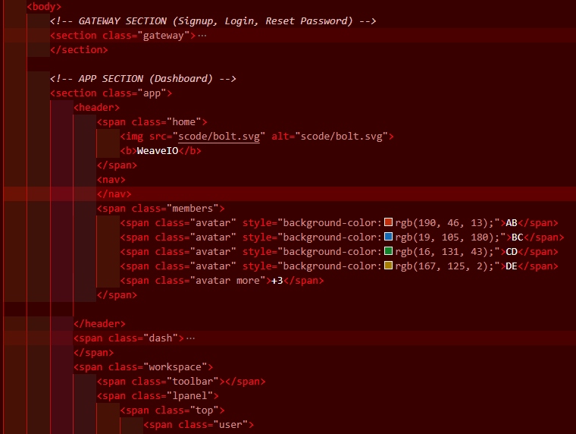

SCRIPT.JS

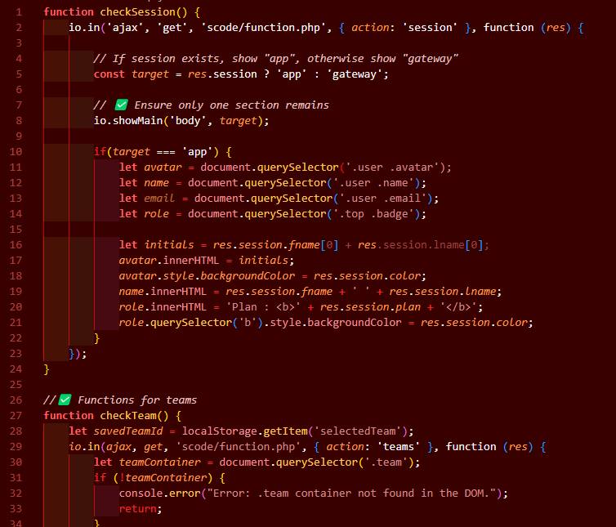

UIGOD.JS

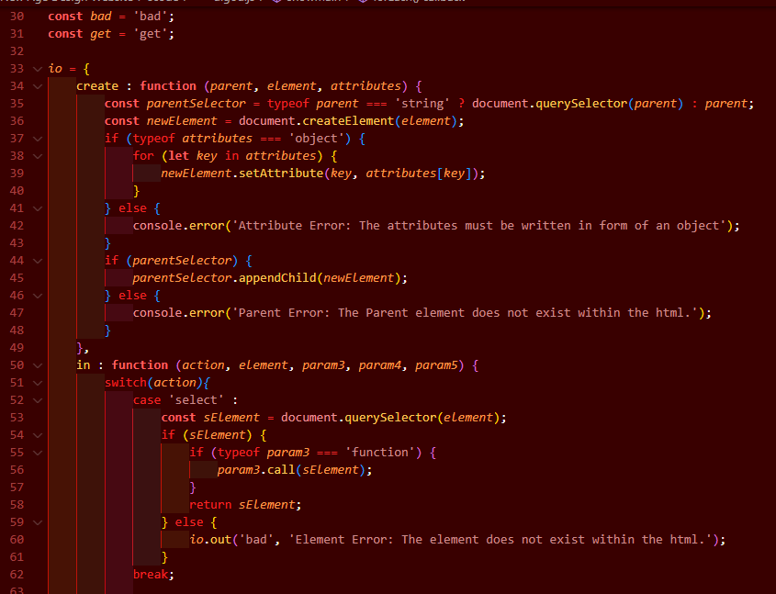

STYLE.CSS

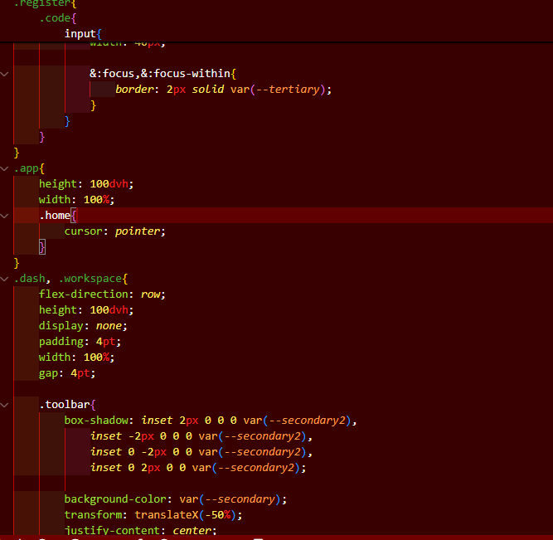

UIGOD.CSS

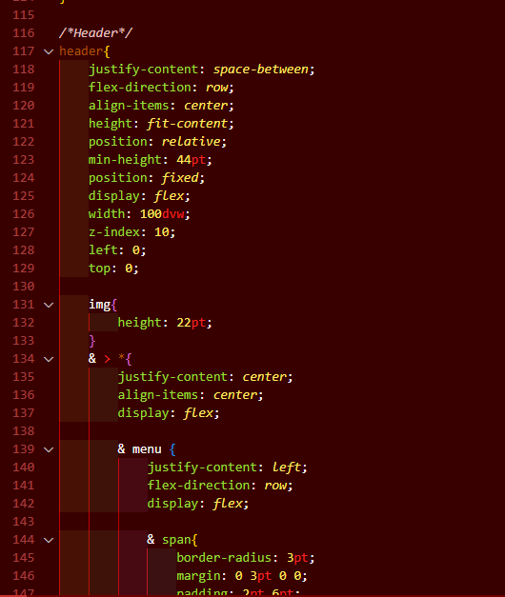

## **4.4 USER INTERFACE DESIGN**

The UI follows **Material Design principles**, ensuring consistency and usability. The color scheme aligns with **modern UI/UX standards**, featuring a dark mode option for improved accessibility.

## **4.5 USER INTERFACE MODULES**

### **4.5.1 Login System**

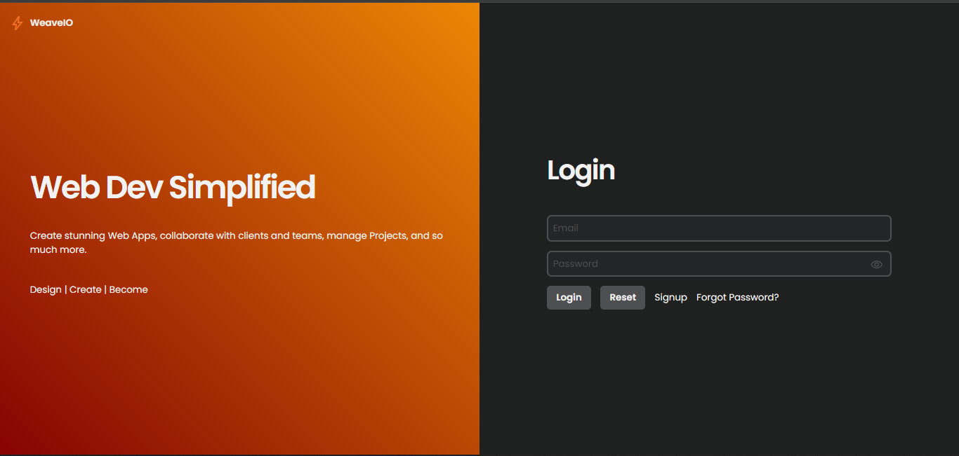

**Explanation:**

* The login system involves signup, login, and reset password form, the signup and login form work, I had issues setting up the email server so I couldn’t work on the reset password form, but I plan to implement that in future.
* Weather you signup or login, a session would be created upon successful submission.

### **4.5.2 Dashboard**

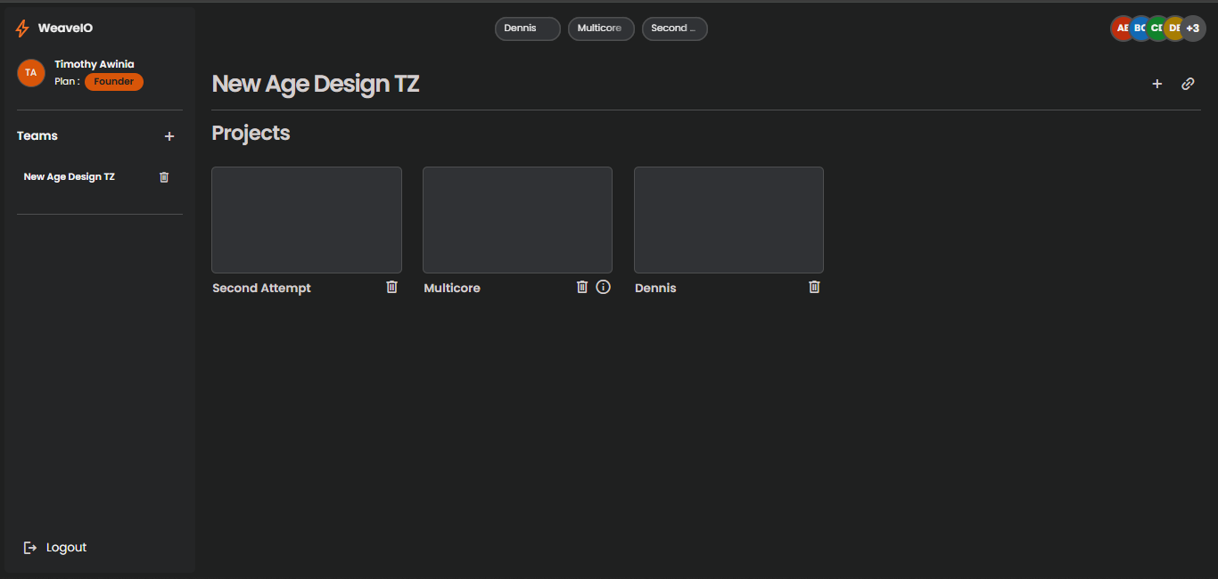

### **4.5.2 Dashboard**

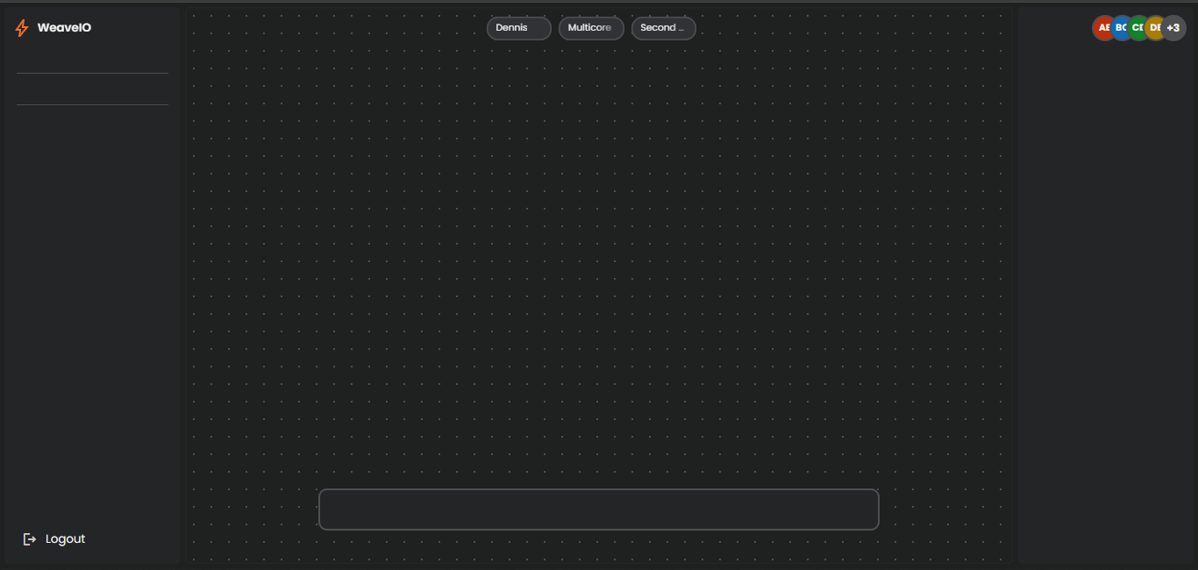

**Explanation:**

* This is where the workspace is, the left panel is for file and component management as well as database schema design using UML and export as MySQL as well as support for other database implementations, the bar at the bottom is the tool bar and is used to access quick components, the right panel is used to access the properties panel, show what the prototype will look like to a client, template selection AI prompting as well as JS scripting (if necessary).

## **4.6 BACK-END DEVELOPMENT**

The back-end is developed using **PHP and MySQL** for UI components. The **RESTful API** manages requests between the front-end and database through **AJAX**.

FUNCTION.PHP

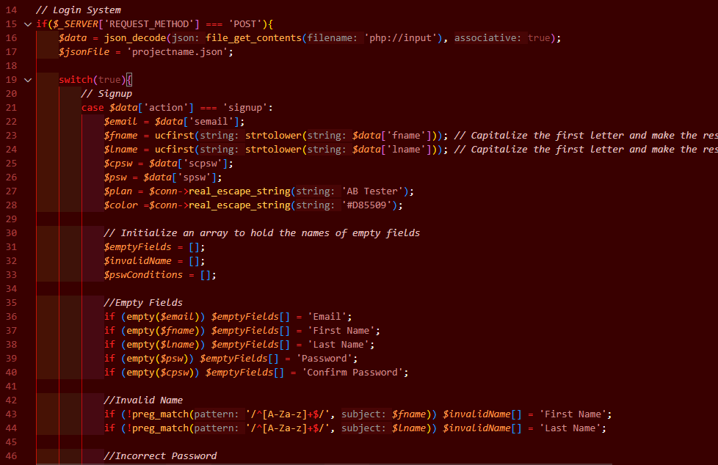

### **4.6.1 Database Design Models**

The database follows a **relational schema**, with tables for **users, teams, projects, tabs, and members**

**UML**

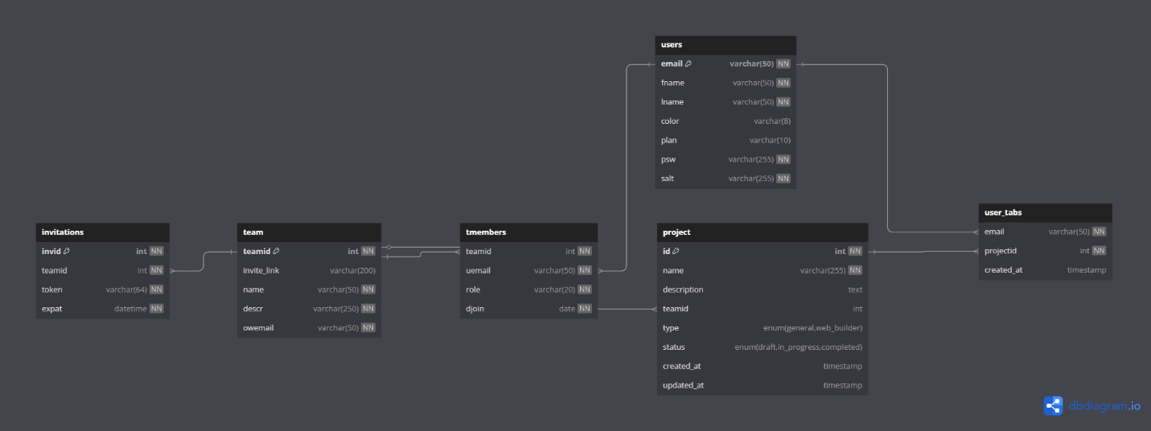

### **4.6.2 Database Tables**

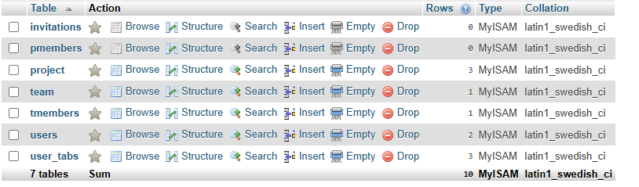

**USERS**

**TEAM**

**TMEMBERS**



**PROJECT**

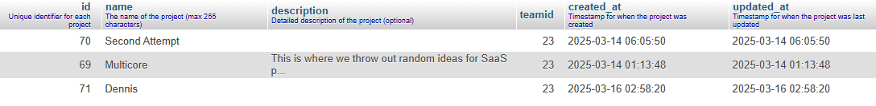

**PMEMBER**



**INVITATION**



**USER_TABS**

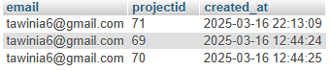

### **4.6.3 Code Testing**

Testing includes:

* **Unit Testing** (Console defined tests, as well as custom errors to display both frontend and backend Errors)
* **Integration Testing** (Console defined tests, as well as custom errors to display both frontend and backend Errors).
* **User Acceptance Testing (UAT)** with real users to gain feedback.

## **4.7 DEPLOYMENT METHODS**

The system was deployed manually to infinityfree.com:

1. **Development Environment:** Locally hosted using WAMP.
2. **Testing Environment:** Since the environment is similar to my server’s environment, this was also done in WAMP.
3. **Production Deployment:** Hosted on **Infinity Free Host as well as server configurations such as MySQL access.**
4. **SSL & Security:** Uses HTTPS, freely provided by infinity free host, a few configurations had to be made.

## **5.0 CONCLUSION AND FUTURE WORK**

This chapter detailed the system implementation and deployment. Future work includes. In conclusion, I have learned a lot from working on this project and what it in tales. I would like in future to test out and finish its other features as well as implement AI driven frontend design and project management tools as well such as diagramming tools, proposal writing, and task, communication and timeline management. I would also like to implement eraser.io APIs to allow users to air out their thoughts and ideas through a process known as whiteboarding.**A: REFERENCE**

* Raymond, D. (2024). Top 10 Cons & Disadvantages of Low-Code No-Code Platforms. projectmanagers.net. <https://projectmanagers.net/top-10-cons-disadvantages-of-low-code-no-code-platforms/?utm_source=chatgpt.com>.
* Fellows, J. (2024). 9 Website Challenges Every Small Business Struggles With. liquidweb.com. https://www.liquidweb.com/blog/business-website-challenges/?utm_source=chatgpt.com.
* John Hughes. (2023, December 2). A Brief History of Website Builders. wpshout. https://wpshout.com/history-of-website-builders/#gref
* Marikyan, D. & Papagiannidis, S. (2023) Technology Acceptance Model: A review. In S. Papagiannidis (Ed), TheoryHub Book. https://open.ncl.ac.uk / ISBN:9781739604400
* Windlinger L., & Tuzcuoglu D. (2021). Usability theory: Adding a user-centric perspective to workplace management. In V. Danivska, & R. Appel-Meulenbroek (Eds.), Routledge (Vol. 1, pp. 173-183). Routledge Taylor & Francis Group.

<https://www.taylorfrancis.com/chapters/oa-edit/10.1201/9781003128786-15/usability-theory-lukas-windlinger-deniz-tuzcuo%C4%9Flu>

* Johnson, A. (2019). "The Impact of Drag-and-Drop Interfaces on User Experience." Journal of Web Development, 15(3), 45-60.
* Smith, B. (2020). "Challenges in Customizing Web Builder Templates." International Journal of Human-Computer Interaction, 32(4), 299-312.
* Williams, C., et al. (2021). "AI-Driven Template Suggestions in Web Builders." Journal of Artificial Intelligence Research, 27(1), 123-140.
* Lee, D. (2022). "Automated SEO Tools: Benefits and Limitations." Search Engine Optimization Quarterly, 14(2), 89-104.
* Brown, E. (2021). "The Role of Educational Resources in Web Builder Success." Educational Technology & Society, 24(3), 77-91.

### **APENDIX C: PROJECT SCHEDULE**

|  |  |  |  |  |  |
| --- | --- | --- | --- | --- | --- |
| **NO.** | **TASK NAME** | **MAY** | **JUNE** | **JULY** | **AUGUST** |
| 1. | Presentation of concept paper |  |  |  |  |
| 2. | Approval of concept paper |  |  |  |  |
| 3. | Research |  |  |  |  |
| 4. | Project Design |  |  |  |  |
| 5. | Project Development |  |  |  |  |
| 6. | Project Deployment and Testing |  |  |  |  |
| 7. | Project Presentation |  |  |  |  |

### **APENDIX D: BUDGET**

|  |  |  |  |
| --- | --- | --- | --- |
| **EXPENCES** | **UNIT** | **COST PER UNIT** | **TOTAL COST** |
| Bundles(Internet) | 20GB | 125/- | 2500/- |
| Printing | 22Pg | 5/- | 110/- |
| Binding | 1 | 50 | 50 |
| Laptop | 1 | 58,000/- | 58,000/- |
| Food and Accommodations | 3 months | 15,000 | 45,000/- |